FAS Applications, Maintenance  
and Enhancements (FAME)

Order Discrepancy Transaction Service Design Document

Document No. X

In response to:

Task Order

Prepared for:

GSA FAS OCIO

2100 Crystal Drive, Suite 1100

Arlington, VA 20406

In support of:

FAS Office of the Chief Information Officer

Prepared by:

Lockheed Martin

Information Systems & Global Services

2345 Crystal Drive, Suite 300

Arlington, VA 22202

June 8th, 2012

Sensitive But Unclassified

This submittal includes SBU information that shall not be disclosed outside the Government and shall   
not be duplicated, used, or disclosed — in whole or in part — for any purpose other than for the Government’s official use under GSA Blanket Purchase Agreement GS-TFMG-BPA-09-0001.   
This restriction does not limit the Government’s right to use the information contained   
herein if it is obtained from another source without restriction.

Approvals

Date  
Lockheed Martin Program Director  
FAS Applications, Maintenance, and Enhancements

Date  
GSA FAS OCIO  
Contracting Officer’s Technical Representative  
FAS Applications, Maintenance, and Enhancements

Document History

|  |  |  |
| --- | --- | --- |
| Version | Description | Date |
| 1.0 | Initial Release | 06/08/2012 |
|  |  |  |
|  |  |  |
|  |  |  |

Table of Contents

1.0 Introduction 5

1.1 Overview 5

1.2 Scope 5

1.3 Architectural Context 5

2.0 Service Overview 6

2.1 Service Operations 6

2.1.1 createDiscrepancyTransactions() 6

2.2 Communication Details 7

2.3 Data Validations 7

2.4 Reliability & Auditing 7

2.5 Class Diagrams 9

2.6 Sequence Diagrams 10

3.0 Security 11

3.1 Message Confidentiality 11

3.2 Identity and Integrity 11

4.0 Models 11

4.1 Domain Model 11

4.2 Message Model 14

5.0 Service WSDL 15

List of Figures

Figure 1: Architectural Overview 5

List of Tables

No table of figures entries found.

# Introduction

The Order Discrepancy Transaction Service Design Document (SDD) describes the rationale and design details of the Order Discrepancy Transaction Service.

## Overview

NCSC customer works on WDC Order discrepancy case on SalesForce platform. When the user closes WDC order discrepancy case on VISS Modernization application, corresponding transactions need to be recorded in the VISS database. Existing VISS back end processes transmits those transaction records to external systems like FSS19 and Financial systems.

## Scope

This service supports WDC Order discrepancy case transactions, which were closed on VISS modernization application.

## Architectural Context

Current VISS application back end process transmits the WDC order discrepancy transactions to external systems on daily basis. As part of VISS Modernization application, all order related case transactions need to be transmitted to existing VISS database. This service provides the interface to record all order related case transactions.

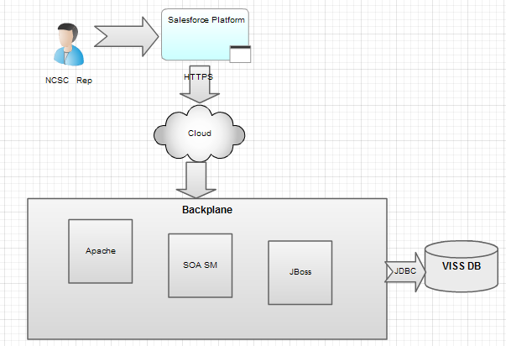

Figure : Architectural Overview

# Service Overview

When user closes the WDC order discrepancy case on VISS modernization application, applies changes to discrepancy item based on following types of transactions.

1. ZKP
2. Finance305
3. Reshipment (A15)
4. Material Return (ZAU)
5. ZLA
6. ZSA
7. VendorOffset

Each type of transaction supports a set of fields need to be inserted into the corresponding tables in the VISS database. Every WDC order discrepancy case close is associated to one or more transactions listed above. Service provides single operation to transmit one or more transactions. If any transaction failure occurs, service operation response provides list of messages for each transaction. If any system error occurs throws ServiceFault.

## Service Operations

### createDiscrepancyTransactions()

|  |  |  |
| --- | --- | --- |
| **Signature** | TransactionsResponse createDiscrepancyTransactions (DiscrepancyTransactions) ServiceFault | |
| **Purpose** | Creates discrepancy transactions which were sent from client. | |
| **Input parameters** | DiscrepancyTransactions – holds zkp, finance305, reshipment, MaterialReturn, zla, zsa, VendorOffset transaction elements. | |
| **Return type** | TransactionsResponse – holds response messages for each transaction | |
| **Pre-conditions** | **Condition** | **Validation Implementation** |
| When case WDC order discrepant item is closed. | Different types of validations for each transaction |
| **Post-conditions** |  | |
| **Exceptions** | ServiceFault exception is raised if any system error happens. | |
| **Invocation style** | Synchronous | |
| **Message exchange pattern** |  | |

## Communication Details

|  |  |
| --- | --- |
| **Interface** | WSDL 1.1 |
| **Communication Protocol** | HTTPS |
| **Communication Method** | SOAP 1.1 |

## Data Validations

Each type of transaction associated to different set of validations. Each data element will be validated, if any validation failure happens returned as service response messages. Some data elements with null or empty values requires padding with blank spaces or “0”s as prefix or suffixes.

## Reliability & Auditing

Message reliability is very important while developing services with financial transactions. In addition to Service implementation, OrderDiscrepancyTransaction service provides continuous assurance for transmitting sensitive data and auditing support.

For any reason, if the VISS database is not accessible, or service failure happens, service provides a retry mechanism to handle cases in which transaction data is not persisted. The framework built for assurance can be used for auditing transactions.

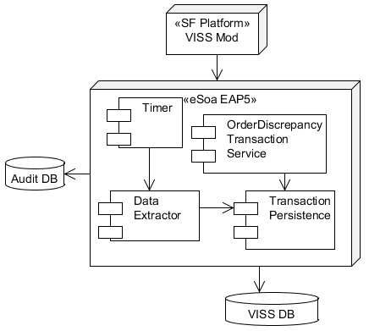

Figure 2: Reliability and Auditing Diagram

## Class Diagrams

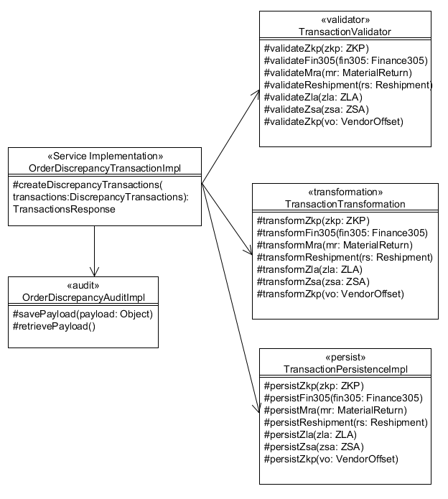

Figure 3: OrderDiscrepancyTransaction Class Diagram

## Sequence Diagrams



# Security

OrderDiscrepancyTransaction service involves with data sensitive financial transactions. So the service will be exposed to the cloud using WS-Security policy.

## Message Confidentiality

Ensuring confidentiality of discrepancy transactions is achieved through Transport Layer Security (SSL).

## Identity and Integrity

XML signature guarantees the XML message integrity. Additionally this mechanism provides support for non-repudiation.

# Models

## Domain Model

<complexType name=*"DiscrepancyItem"*>

<sequence>

<element name=*"niin"* type=*"string"*/>

<element name=*"unitCode"* type=*"glb:string2"*/>

<element name=*"adjustedQuantity"* type=*"int"*/>

<element name=*"requisitionNumber"* type=*"glb:string14"*/>

<element name=*"requisitionSuffix"* type=*"glb:string1"* nillable=*"true"*/>

</sequence>

</complexType>

<complexType name=*"WdcOrderCodes"*>

<sequence>

<element name=*"signalCode"* type=*"glb:string1"* nillable=*"true"*/>

<element name=*"fundCode"* type=*"glb:string2"* nillable=*"true"*/>

<element name=*"projectCode"* type=*"glb:string3"* nillable=*"true"*/>

<element name=*"priorityCode"* type=*"string"* nillable=*"true"*/>

<element name=*"distributionCode"* type=*"glb:string3"* nillable=*"true"*/>

</sequence>

</complexType>

<complexType name=*"AgencyDetails"*>

<sequence>

<element name=*"agencyBureauCode"* type=*"string"*/>

<element name=*"stateCode"* type=*"string"*/>

<element name=*"cityCode"* type=*"string"*/>

</sequence>

</complexType>

<complexType name=*"ZKP"*>

<sequence>

<element name=*"discrepancyKey"* type=*"long"* />

<element name=*"resubmitFlag"* type=*"short"* />

<element name=*"createdUserCode"* type=*"glb:string2"* />

<element name=*"requisitionNumber"* type=*"glb:string14"* />

<element name=*"requisitionSuffix"* type=*"glb:string1"* nillable=*"true"* />

<element name=*"adjustedQuantity"* type=*"int"* />

</sequence>

</complexType>

<complexType name=*"Finance305"*>

<sequence>

<element name=*"discrepancyKey"* type=*"long"* />

<element name=*"resubmitFlag"* type=*"short"* />

<element name=*"discrepancyItem"* type=*"discr:DiscrepancyItem"* />

<element name=*"recordId"* type=*"int"* />

<element name=*"rtgId"* type=*"glb:string3"* />

<element name=*"comCtrCd"* type=*"glb:string1"* nillable=*"true"* />

<element name=*"supplementAddrAAC"* type=*"glb:string6"* nillable=*"true"* />

<element name=*"orderCodes"* type=*"discr:WdcOrderCodes"* />

<element name=*"extSellValue"* type=*"long"* />

<element name=*"sellPrice"* type=*"long"* />

<element name=*"agencyDetails"* type=*"discr:AgencyDetails"* />

<element name=*"exportDomesticCode"* type=*"glb:string1"* />

<element name=*"actionCode"* type=*"glb:string2"* />

<element name=*"manifestPONumber"* type=*"glb:string8"* />

<element name=*"boac"* type=*"glb:string6"* />

<element name=*"region"* type=*"glb:string1"* />

<element name=*"adviceCode"* type=*"string"* />

</sequence>

</complexType>

<complexType name=*"Reshipment"*> <!--A15-->

<sequence>

<element name=*"discrepancyKey"* type=*"long"*/>

<element name=*"resubmitFlag"* type=*"short"*/>

<element name=*"docIdentifierExtension"* type=*"glb:string1"*/>

<element name=*"routingIdentifierCode"* type=*"string"*/>

<element name=*"mediaStatus"* type=*"glb:string1"*/>

<element name=*"discrepancyItem"* type=*"discr:DiscrepancyItem"*/>

<element name=*"supplementAddrAAC"* type=*"glb:string6"* nillable=*"true"*/>

<element name=*"orderCodes"* type=*"discr:WdcOrderCodes"*/>

<element name=*"requiredDeliveryDate"* type=*"string"*/>

<element name=*"adviceCode"* type=*"string"*/>

<element name=*"transportDispositionCode"* type=*"string"*/>

<element name=*"actionCode"* type=*"glb:string2"*/>

<element name=*"createdUserCode"* type=*"glb:string2"*/>

</sequence>

</complexType>

<complexType name=*"MaterialReturn"*> <!--ZAU -->

<sequence>

<element name=*"discrepancyKey"* type=*"long"*/>

<element name=*"resubmitFlag"* type=*"short"*/>

<element name=*"discrepancyItem"* type=*"discr:DiscrepancyItem"*/>

<element name=*"supplementAddrAAC"* type=*"glb:string6"* nillable=*"true"*/>

<element name=*"signalCode"* type=*"glb:string1"* nillable=*"true"*/>

<element name=*"fundCode"* type=*"glb:string2"* nillable=*"true"*/>

<element name=*"routingIdentifierCode"* type=*"string"*/>

<element name=*"adjustedValue"* type=*"long"*/>

<element name=*"createdUserCode"* type=*"glb:string2"*/>

<element name=*"liabilityCode"* type=*"glb:string1"*/>

</sequence>

</complexType>

<complexType name=*"ZLA"*>

<sequence>

<element name=*"discrepancyKey"* type=*"long"*/>

<element name=*"resubmitFlag"* type=*"short"*/>

<element name=*"routingIdentifierCode"* type=*"glb:string3"*/>

<element name=*"returnedUnitCode"* type=*"glb:string1"*/>

<element name=*"discrepancyItem"* type=*"discr:DiscrepancyItem"*/>

<element name=*"supplementAddrAAC"* type=*"glb:string6"* nillable=*"true"*/>

<element name=*"orderCodes"* type=*"discr:WdcOrderCodes"*/>

<element name=*"sellPrice"* type=*"long"*/>

<element name=*"adjustedUnitPrice"* type=*"double"* nillable=*"true"*/>

<element name=*"docIdentifierCode"* type=*"string"*/>

<element name=*"shippedDate"* type=*"dateTime"* nillable=*"true"*/>

<element name=*"costPrice"* type=*"long"*/>

<element name=*"agencyDetails"* type=*"discr:AgencyDetails"*/>

<element name=*"consigneeAAC"* type=*"glb:string6"* nillable=*"true"*/>

<element name=*"poNumber"* type=*"string"*/>

<element name=*"actionCode1"* type=*"glb:string1"*/>

<element name=*"actionCode2"* type=*"glb:string1"*/>

<element name=*"exportDomesticCode"* type=*"glb:string1"* nillable=*"true"*/>

<element name=*"createdUserCode"* type=*"glb:string2"*/>

<element name=*"adviceCode"* type=*"string"*/>

</sequence>

</complexType>

<complexType name=*"ZSA"*>

<sequence>

<element name=*"discrepancyKey"* type=*"long"*/>

<element name=*"resubmitFlag"* type=*"short"*/>

<element name=*"discrepancyItem"* type=*"discr:DiscrepancyItem"*/>

<element name=*"costPrice"* type=*"long"* nillable=*"true"*/>

<element name=*"sellPrice"* type=*"long"* nillable=*"true"*/>

<element name=*"createdUserCode"* type=*"glb:string2"*/>

<element name=*"actionCode"* type=*"glb:string2"*/>

<element name=*"adviceCode"* type=*"string"*/>

</sequence>

</complexType>

<complexType name=*"VendorOffset"*>

<sequence>

<element name=*"discrepancyKey"* type=*"long"*/>

<element name=*"poNumber"* type=*"string"*/>

<element name=*"contractNumber"* type=*"string"*/>

<element name=*"offsetAmount"* type=*"long"*/>

<element name=*"createdUserCode"* type=*"glb:string2"*/>

<element name=*"problemType"* type=*"string"*/>

</sequence>

</complexType>

## Message Model

<complexType name=*"DiscrepancyTransactions"*>

<sequence>

<element name=*"zkp"* type=*"discr:ZKP"* minOccurs=*"0"*/>

<element name=*"finance305"* type=*"discr:Finance305"* minOccurs=*"0"*/>

<element name=*"reshipment"* type=*"discr:Reshipment"* minOccurs=*"0"*/>

<element name=*"materialReturn"* type=*"discr:MaterialReturn"* minOccurs=*"0"*/>

<element name=*"zla"* type=*"discr:ZLA"* minOccurs=*"0"*/>

<element name=*"zsa"* type=*"discr:ZSA"* minOccurs=*"0"*/>

<element name=*"vendorOffset"* type=*"discr:VendorOffset"* minOccurs=*"0"*/>

</sequence>

</complexType>

<complexType name=*"TransactionResponse"*>

<sequence>

<element name=*"isSuccessful"* type=*"boolean"*/>

<element name=*"message"* minOccurs=*"0"* maxOccurs=*"unbounded"*>

<complexType>

<sequence>

<element name=*"code"* type=*"string"* minOccurs=*"0"*/>

<element name=*"message"* type=*"string"* minOccurs=*"0"*/>

</sequence>

</complexType>

</element>

</sequence>

</complexType>

<complexType name=*"TransactionsResponse"*>

<sequence>

<element name=*"isAllSuccessful"* type=*"boolean"*/>

<element name=*"transactionResponse"* type=*"msg:TransactionResponse"* minOccurs=*"0"* maxOccurs=*"unbounded"*/>

</sequence>

</complexType>

# Service WSDL

<wsdl:definitions name=*"OrderDiscrepanyTransaction"*

targetNamespace=*"http://fas.gsa.gov/services/OrderDiscrepancy/v1.0"*

xmlns:tns=*"http://fas.gsa.gov/services/OrderDiscrepancy/v1.0"*

xmlns:soap=*"http://schemas.xmlsoap.org/wsdl/soap/"*

xmlns:wsdl=*"http://schemas.xmlsoap.org/wsdl/"*

xmlns:xsd=*"http://www.w3.org/2001/XMLSchema"*

xmlns:discr=*"http://fas.gsa.gov/OrderDiscrepancy/v1.0"*

xmlns:msg=*"http://fas.gsa.gov/services/Messages/v1.0"*

xmlns:flt=*"http://fas.gsa.gov/Faults/v1.0"*>

<!-- WSDL Types declarations -->

<wsdl:types>

<xsd:schema targetNamespace=*"http://fas.gsa.gov/services/OrderDiscrepancy/v1.0"*

xmlns:tns=*"http://fas.gsa.gov/services/OrderDiscrepancy/v1.0"*

xmlns:discr=*"http://fas.gsa.gov/OrderDiscrepancy/v1.0"*

xmlns:msg=*"http://fas.gsa.gov/services/Messages/v1.0"*

xmlns:flt=*"http://fas.gsa.gov/Faults/v1.0"*

xmlns:xsd=*"http://www.w3.org/2001/XMLSchema"*>

<xsd:import namespace=*"http://fas.gsa.gov/OrderDiscrepancy/v1.0"* />

<xsd:import namespace=*"http://fas.gsa.gov/services/Messages/v1.0"* />

<xsd:import namespace=*"http://fas.gsa.gov/Faults/v1.0"* />

<xsd:element name=*"discrepancyTransactions"* type=*"msg:DiscrepancyTransactions"*/>

<xsd:element name=*"transactionsResponse"* type=*"msg:TransactionsResponse"*/>

<!-- Service fault element -->

<xsd:element name=*"serviceFault"* nillable=*"true"* type=*"flt:ServiceFault"* />

</xsd:schema>

</wsdl:types>

<!-- WSDL Message declarations -->

<wsdl:message name=*"CreateTransactionsRequest"*>

<wsdl:part element=*"tns:discrepancyTransactions"* name=*"discrepancyTransactions"*/>

</wsdl:message>

<wsdl:message name=*"CreateTransactionsResponse"*>

<wsdl:part element=*"tns:transactionsResponse"* name=*"transactionsResponse"*/>

</wsdl:message>

<wsdl:message name=*"ServiceFault"*>

<wsdl:part element=*"tns:serviceFault"* name=*"serviceFault"* />

</wsdl:message>

<!-- WSDL Port Operations -->

<wsdl:portType name=*"OrderDiscrepancyTransaction"*>

<wsdl:operation name=*"createDiscrepancyTransactions"*>

<wsdl:input message=*"tns:CreateTransactionsRequest"*/>

<wsdl:output message=*"tns:CreateTransactionsResponse"*/>

<wsdl:fault message=*"tns:ServiceFault"* name=*"createTransactionsFault"* />

</wsdl:operation>

</wsdl:portType>

<!-- WSDL Binding -->

<wsdl:binding name=*"OrderDiscrepancyTransactionBinding"* type=*"tns:OrderDiscrepancyTransaction"*>

<soap:binding style=*"document"* transport=*"http://schemas.xmlsoap.org/soap/http"*/>

<wsdl:operation name=*"createDiscrepancyTransactions"*>

<wsdl:input>

<soap:body use=*"literal"*/>

</wsdl:input>

<wsdl:output>

<soap:body use=*"literal"*/>

</wsdl:output>

<wsdl:fault name=*"createTransactionsFault"*>

<soap:fault use=*"literal"* name=*"createTransactionsFault"* />

</wsdl:fault>

</wsdl:operation>

</wsdl:binding>

<!-- WSDL Service -->

<wsdl:service name=*"OrderDiscrepancyTransaction"*>

<wsdl:port binding=*"tns:OrderDiscrepancyTransactionBinding"* name=*"OrderDiscrepancyTransactionBinding"*>

<soap:address location=*"http://localhost:8080/order.serivces/OrderDiscrepancyTransaction"*/>

</wsdl:port>

</wsdl:service>

</wsdl:definitions>